Best neighborhoods for Foodies in Valencia, Spain

Introduction
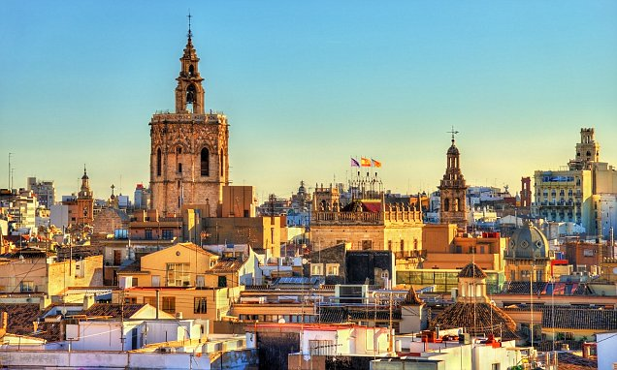
Situated on Spain’s Mediterranean coast, Valencia is a popular tourist destination thanks to its fabulous beaches, provocative street art and ultra-modern City of the Arts and Sciences. But aside from this, Valencia has developed a very impressive food scene aimed for both tourists and locals.

Famous for being the city where Paella was invented, Valencia has much to offer food travelers beyond the iconic rice dish. The Southeastern Spanish city has a bustling central market and plenty of cute cafes where visitors can try local specialties and wash them down with a glass of Horchata or Agua de Valencia.

The goal of the project is to get insights towards what are the best areas for food lovers in Valencia, considering for it geographical information of the city and the Foursquare API for recommendations and prices, ratings and categories.

The target audience for this study is those people who will stay in Valencia for long period of time (from few months to few years) and are willing to explore and discover the hidden gems for food lovers in the city.

